**FAKE NEWS DETECTION USING NLP**

**project overview:**

To identify bogus news, sentiment analysis using NLP can be an effective strategy. NLP algorithms can ascertain the intention and any biases of an author by analyzing the emotions displayed in a news story or social media post. Fake news frequently preys on readers' emotions by using strong language or exaggeration.

**problem definition:**

Fakebox analyzes linguistic characteristics of news articles to assess whether they are likely to be real news or not. By looking at different aspects of an ar- ticle (title, content and URL), using NLP models and training on a manually curated database, Fakebox can successfully identify fake news.

**Designing thinking:**

Design thinking is a problem-solving approach that emphasizes empathy, creativity, and collaboration to generate innovastage solutions. It typically involves the following stages:

**1.Data Collection:**

Gather a dataset of both real and fake news articles.

**2.Text Preprocessing:**

Clean and preprocess the text data by removing stopwords, special characters, and performing tokenization.

**3.Feature Extraction:**

Use NLP techniques like TF-IDF (Term Frequency-Inverse Document Frequency) or word embeddings (e.g., Word2Vec, GloVe) to convert text into numerical features.

**4.Model Selection:**

Choose an appropriate NLP model, such as recurrent neural networks (RNNs), convolutional neural networks (CNNs), or transformer-based models like BERT or GPT, for text classification.

**5.Training:**

Train the selected model on the labeled dataset. Fine-tuning pre-trained models like BERT is often very effective**.**

**6.Evaluation:**

Use metrics like accuracy, precision, recall, and F1-score to assess the model's performance on a separate test dataset.

**ARCHITECTURE FOR FAKE NEWS DETECTION USING NLP**

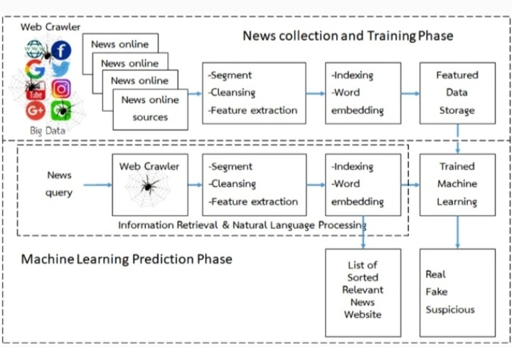

**Flowchart**

**web crawler-based information retrieval frame work**

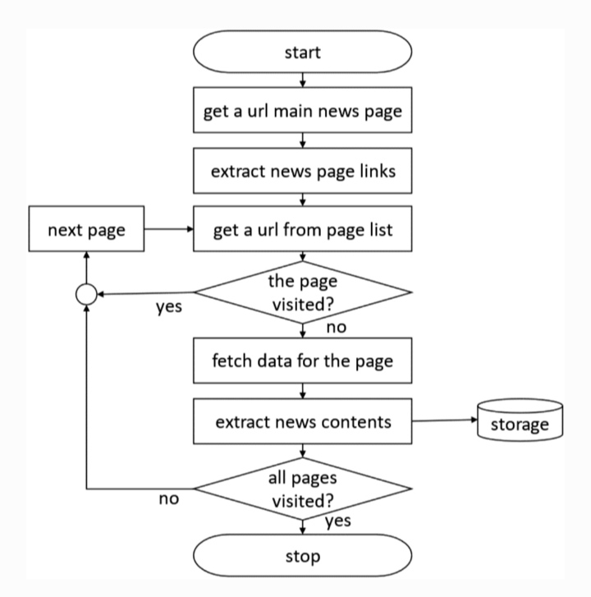

**natural language processing frame work**

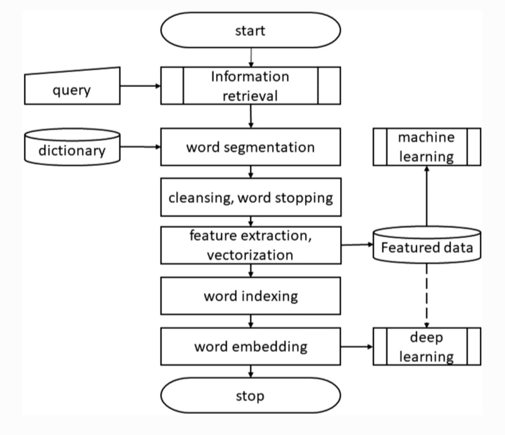

**User diagram for fake news detection using nlp**

